**SECTION A-46 MARKS**

**Attempt** all **questions in this section.**

1. The standard electrode potential for some redox systems are shown below:

VO2+(aq) + 2H+(aq) + e  V3+(aq) + H2O(l) Eθ = +0.34V.

MnO2(s) + 4H+(aq) +2e Mn2+(aq) + 2H2O(l) Eθ = +1.23V.

1. Write: (@01½ marks)
2. The cell notation for the cell formed when the half-cells are combined.

……………………………………………………………………………………………………………………………………………………………………

1. The overall equation for the reaction.

……………………………………………………………………………………………………………………………………………………………………

1. Calculate the e.m.f of the cell in (a) above. (01½ marks)

………………………………………………………………………………………………………………………………………………………………………………………………………………………………………………………

1. State whether the cell reaction in a (i) is feasible or not. Give a reason for your answer. (01 mark)

……………………………………………………………………………………………………………………………………………………………………

1. Name the reagent that can be used to distinguish between the following pair of compounds. State the observations made. (@03 marks)
2. CH3CH2CHO and CH3COCH2CH3.

Reagent:

……………………………………………………………………………………………………………………………………………………………………

Observation:

………………………………………………………………………………………………………………………………………………………………………………………………………………………………………………………

1. Phenol and 2-phenylethanol.

Reagent:

……………………………………………………………………………………………………………………………………………………………………

Observation:

………………………………………………………………………………………………………………………………………………………………………………………………………………………………………………………

1. Vegetable oils are used as raw materials in manufacture of soap.
2. Explain what is meant by the term vegetable oil. (01 mark)

……………………………………………………………………………………………………………………………………………………………………………………………………………………………………………………………………………………………………………………………………………………

1. Name any one source from which vegetable oil can be obtained. (0½ mark)

……………………………………………………………………………………

1. Describe briefly how soap is obtained from vegetable oil. (02 marks)

…………………………………………………………………………………………………………………………………………………………………………………………………………………………………………………………………………………………………………………………………………………………………………………………………………………………………………………………………………………………………………………………………………………………………………………………………………………………………………………………………………………………………………

1. Write general equation for the reaction leading towards formation of soap from vegetable oil. (01 mark)

…………………………………………………………………………………………………………………………………………………………………………………………………………………………………………………………………………………………………………………………………………

1. Lithium and magnesium show similarities in some of their chemical properties however their carbides react differently with water.
2. State reasons why the chemical properties of lithium resemble that of magnesium. (01½ marks)

…………………………………………………………………………………………………………………………………………………………………………………………………………………………………………………………………………………………………………………………………………………………………………………………………………………………………………

1. Write equations for the reactions of carbides of lithium and magnesium with water. (02 marks)

……………………………………………………………………………………………………………………………………………………………………………………………………………………………………………………………………………………………………………………………………………………

1. To a mixture of manganese (IV) oxide and solid sodium chloride was added a few drops of concentrated sulphuric acid and the mixture warmed.
2. State what was observed. (0½ mark)

……………………………………………………………………………………………………………………………………………………………………

1. Write equation for the reaction that took place. (01½ marks)

……………………………………………………………………………………………………………………………………………………………………

1. Excess of the gaseous product formed in (a) above was bubbled through aqueous solution of sodium thiosulphate.
2. State what was observed. (01 mark)

……………………………………………………………………………………………………………………………………………………………………

1. Write equation for the reaction that took place. (01½ marks)

……………………………………………………………………………………………………………………………………………………………………

1. Draw and shape the boron trifluoride.

Shape:

…………………………………………………………………………………

Name of the shape:

…………………………………………………………………………………

1. Comment on polarity of boron trifluoride and explain your answer. (02½ marks)

…………………………………………………………………………………………………………………………………………………………………………………………………………………………………………………………………………………………………………………………………………………………………………………………………………………………………………………………………………………………………………………………………………………………………………………………………………………………………………………………………………………………………………………………………………………………………………………………………………………………………………………………………………………..

1. Write equation for the reaction between boron trifluoride and ammonia. (01 mark)

……………………………………………………………………………………………………………………………………………………………………

1. Explain what is meant by the term order of a reaction. (01 mark)

……………………………………………………………….………………………………………………………………………………………………………………………………………………………………………………………………………………………………………………………………………………………………………………………………………………………………………………………………………………………………………………………………

1. The rate equation for a reaction between substances A, B & C is in the form of: Rate of reaction=constant, k [A]x[B]y[C]z

|  |  |  |  |  |
| --- | --- | --- | --- | --- |
| Experiments | Initial [A] mol/ℓ | Initial [B] mol/ℓ | Initial [C] mol/ℓ | Initial rate [mol/ℓ3/s |
| 1 | 0.10 | 0.20 | 0.20 | 8.0 x 10-5 |
| 2 | 0.10 | 0.05 | 0.20 | 2.0 x 10-5 |
| 3 | 0.05 | 0.10 | 0.10 | 1.0 x 10-5 |
| 4 | 0.10 | 0.10 | 0.10 | 2.0 x 10-5 |

Use the data in the table to determine the order of reaction with respect to A, B & C respectively. (@01½ marks)

1. A.

……………………………………………………………….…………………………………………………………………………………………………………………………………………………………………………………………………………………………………………………………………………………………………………………………………………………………………………………………………………………………………………………………………………………………………………………………………………………………………………………………………………………

1. B.

……………………………………………………………….…………………………………………………………………………………………………………………………………………………………………………………………………………………………………………………………………………………………………………………………………………………………………………………………………………………………………………………………………………………………………………………………………………………………………………………………………………………

1. C.

……………………………………………………………….………………………………………………………………………………………………………………………………………………………………………………………………………………………………………………………………………………………………………………………………………………………………………………………………………………………………………………………………………………………………………………………………

1. Determine the value of rate constant. (01 mark)

……………………………………………………………….…………………………………………………………………………………………………………………………………………………………………………………………………………………………………………………………………………………………………………………………………………………………………………………………………………………………………………………………………………………………………………………………………………………………………………………………………………………

1. Explain what is meant by term first ionization energy. (01 mark)

……………………………………………………………….…………………………………………………………………………………………………………………………………………………………………………………………………………………………………………………………………………………………………………………………………………………………………………………………………………………………………………..

1. The 1st, 2nd, 3rd & 4th ionization energies of element, M are **800, 2,400, 3,700** & **25,000 kJ/mol** respectively. State and explain the trend in variation in ionization energies of element, M. (02½ marks)

………………………………………………………………………………………………………………………………………………………………………………………………………………………………………………………………………………………………………………………………………………………………………………………………………………………………………………………………………………………………………………

1. State the type of bond and structure that exists in the chloride formed by element, M. (@0½ mark)

Type:

…………………………………………………………………………………

Structure:

………………………………………………………………………………..

1. Give a reason for your answer in (c). (01 mark)

………………………………………………………………………………………………………………………………………………………………………………………………………………………………………………………

1. State Graham’s law diffusion. (01 mark)

……………………………………………………………………………………………………………………………………………………………………………………………………………………………………………………………………………………………………………………………………………………

1. Compound, T with formula Ni(CO)X takes **46** minutes to diffuse through a porous medium. An equal volume of oxygen gas takes **19.90**minutes to diffuse through the same medium under the same conditions. The vapour density of compound, T is **85.35**. Determine the molecular formula of compound, T. (03 marks)

……………………………………………………………………………………………………………………………………………………………………………………………………………………………………………………………………………………………………………………………………………………………………………………………………………………………………………………………………………………………………………………………………………………………………………………………………………………………………………………………………………………

1. Name compound, T and state the co-ordination number of nickel in the compound. (@0½ mark)

Name:

…………………………………………………………………………………

Co-ordination number:

…………………………………………………………………………………

**SECTION B-54 MARKS**

**Attempt** ANY **SIX questions in this section.**

1. Explain what is meant by term steam distillation. (01 mark)

………………………………………………………………………………………………………………………………………………………………………………………………………………………………………………………………………………………………………………………………………………………………………………………………………………

1. Compound, Y contains carbon, hydrogen and nitrogen. On analysis of **1.86g** of compound, Y produced **5.28g** of carbon dioxide and **224cm3** of nitrogen measured at S.T.P. Determine the empirical formula of compound, Y. (03 marks)

………………………………………………………………………………………………………………………………………………………………………………………………………………………………………………………………………………………………………………………………………………………………………………………………………………………………………………………………………………………………………………………………………………………………………………………………………………………………………………………………

1. A mixture of compound, Y and water was steam distilled. The mixture boiled at a temperature **96ᵒC** and pressure of **760mmHg.** The saturated vapour of water at the same temperature is **722mmHg**. The distillate contains **78.61%** by mass water.
2. Determine the molecular mass of compound, Y.(02 marks)

………………………………………………………………………………………………………………………………………………………………………………………………………………………………………………………………………………………………………………………………………………………………………………………………………………………………………………………………………………………………………………………………………………………………………………………………………………………………………………………………………………………………………………………………………………………………………………………………………………………………

1. Determine the molecular formula of compound, Y. (01 mark)

………………………………………………………………………………………………………………………………………………………………………………………………………………………………………………………………………………………………………………………………………………………………………………………………………………………………………………………………………………………………

1. Compound, Y forms white precipitate with bromine water.
2. Identify compound, Y. (0½ mark)

………………………………………………………………………………..

1. Cold concentrated hydrochloric acid and sodium nitrite was added to compound, Y and to the resultant solution was added Naphthalen-2-ol in presence of sodium hydroxide solution. State what was observed and write equation for the reaction that takes place between the resultant solution and 2-Naphthalen-2-ol.

………………………………………………………………………………………………………………………………………………………………………………………………………………………………………………………………………………………………………………………………………………………………………………………………………………………………………………………………………………………………

1. Copper (II) ethanoate was strongly heated until there was no further change.
2. State what was observed. (01 mark)

………………………………………………………………………………………………………………………………………………………………

1. Write equation for the reaction that took place. (01½ marks)

………………………………………………………………………………………………………………………………………………………………

1. When the gaseous product formed in (a) was passed through 2,4-dinitrophenylhydrazine in acidic media a compound, Q was formed. Outline the reaction mechanism for the reaction leading towards formation of compound, Q. (05½ marks)

……………………………………………………………………………………………………………………………………………………………………………………………………………………………………………………………………………………………………………………………………………………………………………………………………………………………………………………………………………………………………………………………………………………………………………………………………………………………………………………………………………………………………………………………………………………………………………………………………………………………………………………………………………………………………………………………………………………………………………………………………………………………………………………………………………..

1. Write equation (s) to show how the gaseous product that reacted with 2,4-dinitrophenylhydrazine in acidic media to form compound, Q can be synthesized from a carboxylic acid. Indicate the necessary reagents and conditions. (01 mark)

………………………………………………………………………………………………………………………………………………………………………………………………………………………………………………………………………………………………………………………………

1. Strontium fluoride is a sparingly soluble salt.
2. Write equation for solubility of strontium fluoride in water. (01 mark)

………………………………………………………………………………

1. Write the expression for solubility product of strontium fluoride. (01 mark)

………………………………………………………………………………

1. The solubility of strontium fluoride in water at room temperature is **0.109g/dm3**. Calculate the solubility product of strontium fluoride. (02½ marks)

………………………………………………………………………………………………………………………………………………………………………………………………………………………………………………………………………………………………………………………………………………………………………………………………………………………………………………………………………………………………………………………………………………………………………………………………………………………………………………………………………………………………………………………………………………………………………………………………………………………………

1. Calculate the solubility of strontium fluoride in 0.1M aqueous solution of strontium nitrate. (02½ marks)

………………………………………………………………………………………………………………………………………………………………………………………………………………………………………………………………………………………………………………………………………………………………………………………………………………………………………………………………………………………………………………………………………………………………………………………………………………………………………………………………………………………………………………………………………………………………………………………………………………………………

1. State and explain what would happen to the solubility of strontium fluoride when potassium fluoride is added. (01½ marks)

………………………………………………………………………………………………………………………………………………………………………………………………………………………………………………………………………………………………………………………………………………………………………………………………………………………………………………………………………………………………………………………………………………………………………………………………………………………………………………………………

1. State one application solubility product. (0½ mark)

………………………………………………………………………………………………………………………………………………………………

1. A compound, R contains by mass **90.66%** lead and the rest oxygen. Molar mass compound, R is **684.9**.
2. Determine the empirical formula of compound, R. (02 marks)

………………………………………………………………………………………………………………………………………………………………………………………………………………………………………………………………………………………………………………………………………………………………………………………………………………………………………………………………………………………………………………………………………………………………………………………………………………………………………………………………………………………………………………………………………………………………………………………………………………………………

1. Calculate the molecular formula of compound, R.(01 mark)

………………………………………………………………………………………………………………………………………………………………………………………………………………………………………………………………………………………………………………………………………………………………………………………………………………………………………………………………………………………………

1. Compound, R was warmed together with dilute nitric acid until there was no further change. Write equation for the reaction that took place. (01½ marks)

………………………………………………………………………………………………………………………………………………………………

1. The mixture formed in (b) was filtered and the residue was added to aqueous solution of manganese nitrate then followed by concentrated nitric acid. State what was observed and write equation for the reaction that took place.

………………………………………………………………………………………………………………………………………………………………………………………………………………………………………………………………………………………………………………………………

1. To the filtrate obtained in (c) was added ammonium chromate solution followed by sodium hydroxide solution. State what was observed and write equation(s) for the reaction(s) that took place.

………………………………………………………………………………………………………………………………………………………………………………………………………………………………………………………………………………………………………………………………

1. Explain what is meant by term enthalpy of formation. (01 mark)

………………………………………………………………………………………………………………………………………………………………………………………………………………………………………………………………………………………………………………………………

1. Given that the heat of combustion of carbon, hydrogen and ethanoic acid are **-394**, **-286** & **- 878** respectively. Calculate the enthalpy of ethanoic acid. (03½ marks)

………………………………………………………………………………………………………………………………………………………………………………………………………………………………………………………………………………………………………………………………………………………………………………………………………………………………………………………………………………………………………………………………………………………………………………………………………………………………………………………………………………………………………………………………………………………………………………………………………………………………

1. Define the the term bond energy. (01 mark)

………………………………………………………………………………………………………………………………………………………………………………………………………………………………………………………………………………………………………………………………

1. The enthalpies of atomization of carbon, oxygen & hydrogen are **721**, **249** & **218kJ/mol** respectively while the bond energies of C-C, C=O, C-O & O-H are **347**,**743**, **358** & **463kJ/mol** respectively. Use the information given above to calculate the bond energy of C-H in ethanoic acid in a (ii). (03½ marks)

……………………………………………………………………………………………………………………………………………………………………………………………………………………………………………………………………………………………………………………………………………………………………………………………………………………………………………………………………………………………………………………………………………………………………………………………………………………………………………………………………………………………………………………………………………………………………………………………………………………………………………………………………………………………………………………………………………………………………………………………………………………………………………………………………………………………………………………………………………………………………………………………………

1. During manufacture of nitric acid, Ammonia is catalytically oxidized.
2. Write equation for the reaction. (01½ marks)

………………………………………………………………………………………………………………………………………………………………

1. Name the catalyst used. (0½ mark)

………………………………………………………………………………

1. State other two specific optimum conditions employed. (01 mark)

………………………………………………………………………………………………………………………………………………………………………………………………………………………………………………

1. **1** mole of nitrogen monoxide gas formed in (a) was heated together with **2** moles of oxygen gas in **1** litre closed vessel and the reaction that took place is as shown below: 2NO(g) + O2(g)  2NO2(g) When equilibrium was attained it was established that **36%** of the nitrogen monoxide gas had reacted. Determine the equilibrium constant, Kc for the reaction. (03 marks)

………………………………………………………………………………………………………………………………………………………………………………………………………………………………………………………………………………………………………………………………………………………………………………………………………………………………………………………………………………………………………………………………………………………………………………………………………………………………………………………………………………………………………………………………………………………………………………………………………………………………

1. Write equation for the reaction of warm moderately concentrated nitric acid with: (@01½ marks)
2. Lead:

………………………………………………………………………………………………………………………………………………………………

1. Magnesium:

………………………………………………………………………………………………………………………………………………………………

1. Write equations to show how the following synthesis can be carried out. In each case, indicates the necessary conditions and reagents.
2. Cyclohexanone from chlorobenzene. (03½ marks)

………………………………………………………………………………………………………………………………………………………………………………………………………………………………………………………………………………………………………………………………………………………………………………………………………………………………………………………………………………………………………………………………………………………………………………………………………………………………………………………………………………………………………………………………………………………………………………………………………………………………

1. CH3COOCH3 from CH3MgBr. (02½ marks)

………………………………………………………………………………………………………………………………………………………………………………………………………………………………………………………………………………………………………………………………………………………………………………………………………………………………………………………………………………………………………………………………………………………………………………………………………………………………………………………………………………………………………………………………………………………………………………………………………………………………

1. 2-phenylpropane from 1-bromopropane. (03 marks)

………………………………………………………………………………………………………………………………………………………………………………………………………………………………………………………………………………………………………………………………………………………………………………………………………………………………………………………………………………………………………………………………………………………………………………………………………………………………………………………………………………………………………………………………………………………………………………………………………………………………

1. Write a mechanism to show how each of the following conversions can be effected.
2. (CH3)2CBrCH2CH3 (CH3)2C(OH)CH2CH3 (02½ marks)

………………………………………………………………………………………………………………………………………………………………………………………………………………………………………………………………………………………………………………………………………………………………………………………………………………………………………………………………………………………………………………………………………………………………………………………………………………………………………………………………………………………………………………………………………………………………………………………………………………………………

1. Benzene Benzene sulphonic acid. (03½ marks)

………………………………………………………………………………………………………………………………………………………………………………………………………………………………………………………………………………………………………………………………………………………………………………………………………………………………………………………………………………………………………………………………………………………………………………………………………………………………………………………………………………………………………………………………………………………………………………………………………………………………

1. Methylcyclohexene methylcyclohexanol. (02½ marks)

………………………………………………………………………………………………………………………………………………………………………………………………………………………………………………………………………………………………………………………………………………………………………………………………………………………………………………………………………………………………………………………………………………………………………………………………………………………………………………………………………………………………………………………………………………………………………………………………………………………………

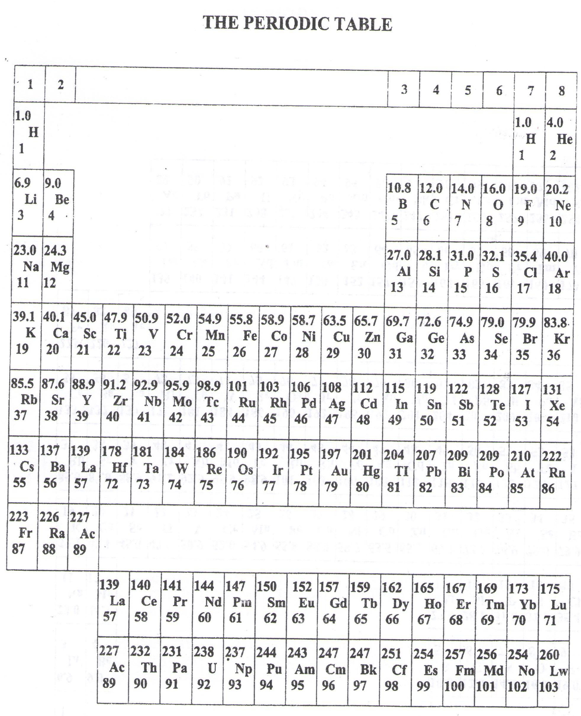

* ===END===

WELCOME TO SENIOR SIX, YEAR 2023

This is the last page of the printed paper, Page 22